**import pandas as pd**

**dataset=pd.read_csv('D:\CDAC PG-DBDA Course\Machine learning\Day 4\player.csv')**

**dataset**

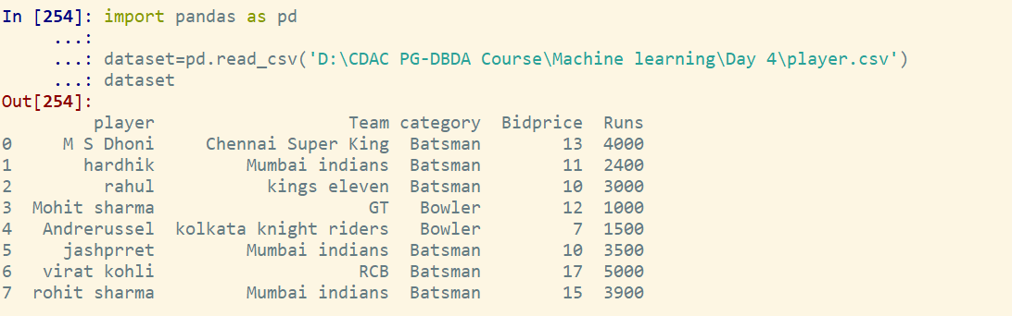

**Q1. display all bowlers.**

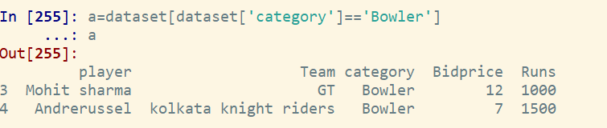

**Q2 Display all players of mumbai Indians.**

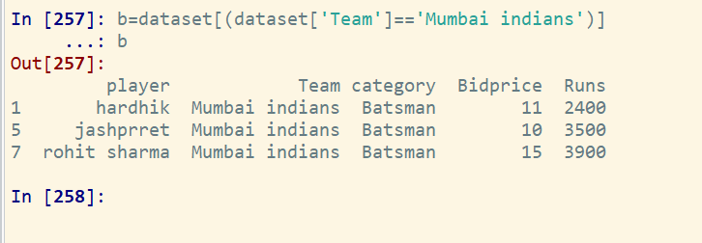

**Q3. Display all mumbai indian players with run greater than 3000.**

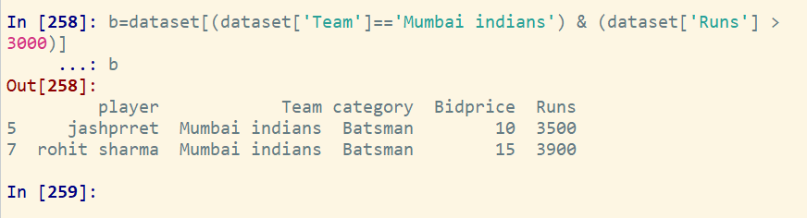

**Q4. display the details of players who play for RCB or chennai super king**

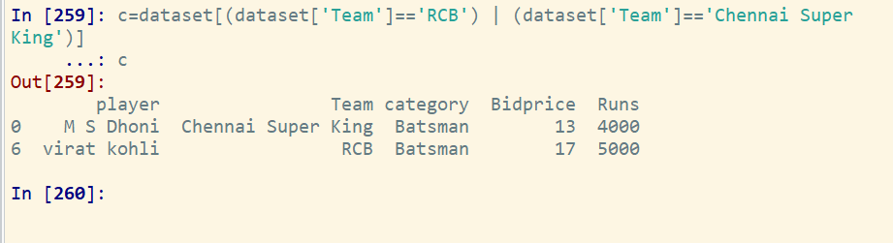

**Q5. print the average bid price and run**

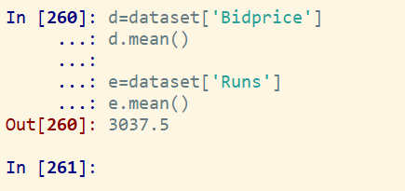

**Q6. sort the player by the bidding price.**

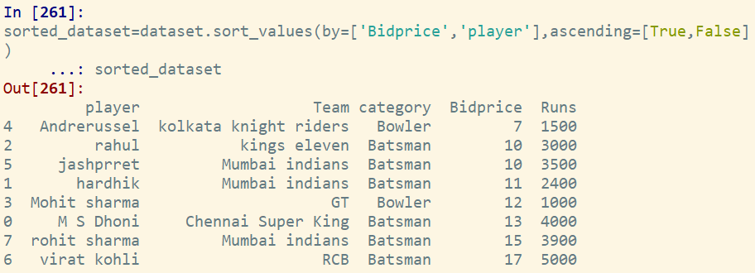

**Q7.find most expenssive player**

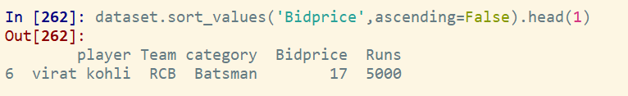

**Q8.find the player with lowest run**

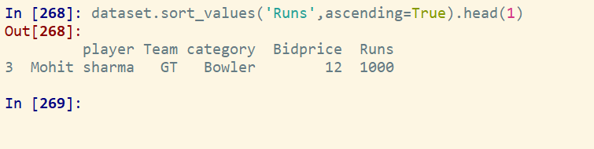

**Q9. print the total player/no. of rows in a dataset**

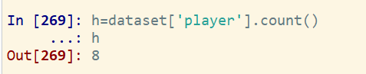

**Q10. print total players per each team**

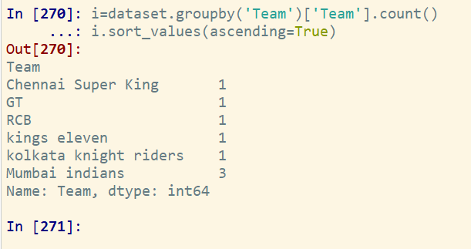

**Q11. find player who had highest bid price from each team**

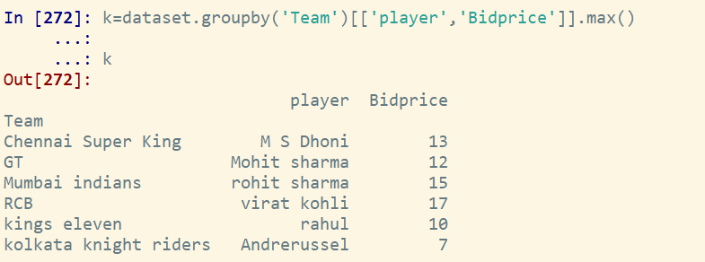

**Q12. Find the average run for each team**

